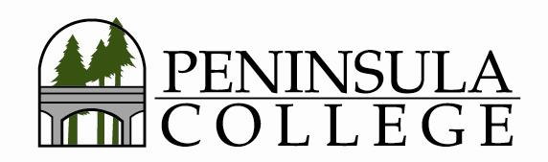
Special Meeting of the Board of Trustees
April 11, 2022, 4:30 p.m.
Cornaby Center (A-12)

Trustees:
Mike Glenn, Chair  Dwayne Johnson, Vice Chair  Mike Maxwell  Joe Floyd  Claire Roney | ROLL CALL and DETERMINATION OF QUORUM  MODIFICATION TO AGENDA  PUBLIC FORUM  EXECUTIVE SESSION  ADJOURNMENT

